Group Pandemic Management Plan
March 2020

Table of Contents
1 Glossary 4
2 Information About this Document 5
3 Introduction 6
4 Purpose and Scope 6
5 Principles of Pandemic Management 6
6 Pandemic Management Strategy 7
7 Pandemic Phases 7
8 Pandemic Management Organisation 8
9 Pandemic Reporting and Communications 8
10 Workplace Pandemic Supplies and Resources 9
11 Risk Management 9
12 Review and Improvement 10
13 Training, Testing and Exercising 10
Annex A: Roles and Responsibilities 11
Annex B: Key Pandemic Management Contacts 15
Annex C: Suspected Pandemic Influenza Case Response & Reporting 16
Annex D: Register of Influenza Case History 20
Annex E: Pandemic Case Contact Trace Register 21
Annex F: Privacy and Ethical Considerations 22
Annex G: Face Masks 23
Annex H: Pandemic Flu Policies 24

Glossary
BCM | Business Continuity Management. A holistic management process that identifies potential impacts that threaten an organisation and provides a framework for building resilience that safeguards the interests of its key stakeholders, reputation, brand and value creating activities. Also relates to management of the overall Program through training, rehearsals, and reviews, to ensure that Plans remain current and up to date.
BCP | Business Continuity Plan/Plans/Planning. These plans are designed to provide direction for the continuity of key business processes during/following a disruptive event.
CMP | Crisis Management Plan. The CMP is utilised by the CMT to effectively manage to a crisis.
CMT | Crisis Management Team. A team consisting of senior ORGANISATION executives and key role players (i.e. media representative, legal counsel, crisis coordinator, etc.) who are responsible for resourcing operations and communicating to stakeholders during a crisis.
Emergency | An unexpected or impending situation that may cause injury, loss of life, destruction of property, or cause the interference, loss, or disruption of an organization’s normal business operations to such an extent that it poses a threat. An emergency may quickly lead to a crisis situation.
ECO | Emergency Control Organisation. The group of people formally assigned emergency management tasks within an EMP (e.g. Wardens).
EMP | Emergency Management Plan. A documented plan designed to address the response to an emergency situation; focused on safety of life during presenting threat.
Pandemic | The worldwide spread of a new disease.
PMG | Pandemic Management Group. A senior cross-functional group that works on behalf of the CMT to manage pandemic response on a day-to-day basis.
PMO | Pandemic Management Organisation. This is a term used to describe all personnel involved in authorising, advising, implementing and/or managing pandemic arrangements (as defined within this plan).
WHO | World Health Organisation.

Information About this Document

Document Management and Control
Creation | Name | Role | Date
AUTHOR | NAME | ROLE | DATE
REVIEWED
REVIEWED
REVIEWED
REVIEWED
REVIEWED
APPROVED

Version | Date | Description of Change | Approved By
1.0 | DATE | Initial publication. | ROLE

Enquiries about this Document
For enquiries about this document contact the Pandemic Management Group Leader (details appear at Annex B - Key Pandemic Management Contacts).

Useful Pandemic Related Resources and Documents
- ORGANISATION Business Resilience Policy.
- ORGANISATION Crisis Management Plan.
- ORGANISATION Business Continuity Plans.
- ORGANISATION Emergency Management Plans.
- US Centre for Disease Control (www.cdc.gov).
- World Health Organisation (www.who.int/csr/disease/en).

Introduction
This Pandemic Management Plan (PMP) has been prepared to assist ORGANISATION to react quickly and positively in times of pandemic.
Despite continued advances in medicine, science and technology, all organisations remain susceptible to new and re-emerging infectious diseases. While it is likely that this susceptibility would only last until such time as community level immunity is established, or effective vaccines and treatments can be developed, it nevertheless requires the ORGANISATION to be prepared to respond rapidly to outbreaks whenever and wherever they occur.
In the modern global economy, pandemics will affect almost everyone to at least some degree. The peak of a pandemic phase may last 7-10 months and will cause significant and medium-long-term impacts to the business globally.
ORGANISATION must be prepared to act quickly and positively to:
- Protect the life and health of ORGANISATION workers.
- Maintain service continuity and the trust of our customers and partners.
- Minimise the impact to operations caused by absenteeism, sickness and quarantine.
- Cooperate with government wherever necessary.
- Communicate and maintain the confidence of internal and external stakeholders.

Purpose and Scope
The purpose of this PMP is to detail arrangements for the enactment of a coordinated process to effectively manage all stages of a pandemic.
The response arrangements within this Plan should not be used in a completely prescriptive manner and without an assessment of the situational context that presents as a pandemic unfolds. In certain situations, especially where the level of alert differs between domestic and international jurisdictions, it is appropriate to reassess and modify the approach recommended within this document.
Arrangements are applicable to ORGANISATION personnel and others involved in pandemic related management activities on behalf of the organisation, wherever they are located. This group is collectively referred to as ORGANISATION’s ‘pandemic management organisation’.

Principles of Pandemic Management
- Consideration of workers and Workplace/Occupational Health and Safety (W/OHS) is paramount in all decision making.
- Privacy concerns should be factored into decision making, but also consider the health and safety of others in making decisions that might result in the release of personally identifiable information (refer to Annex F for privacy and other ethical decision-making considerations).
- Pandemic directions must be clear in purpose, communicated to those with appropriate authority and capability to implement them, and be consistent with general strategies for managing a pandemic.
- Pandemic arrangements must be continually reviewed, tested and improved. They must also be realistic, resourced and flexible, and supported by management at all levels.
- Pandemic management includes: planning and coordination; situation monitoring and assessment; communications; reducing the spread of disease and continuity of assistance to staff and customers.

Pandemic Management Strategy
This Plan is designed to integrate within the broader Business Resilience Program. Actions and arrangements do not specifically focus on continuity of functions and processes, but rather in defining measures that prepare and minimise the risk of infection and reduce the spread rate and impact, should worker infection occur.
This Plan is designed to be implemented by the Pandemic Management Group (PMG) and provide guidance and coordinating direction to the wider PMO.
Arrangements within this Plan directly align with pandemic management stages designed by the World Health Organisation (WHO).

Pandemic Phases
Adopting the WHO’s approach to pandemic phases assists ORGANISATION to maximise coordination in terms of declarations and actions recommended by authorities. The diagram below is a modified version of that recognised by WHO, and it illustrates each of the phases and the criteria used to assess them (subject to official declarations).
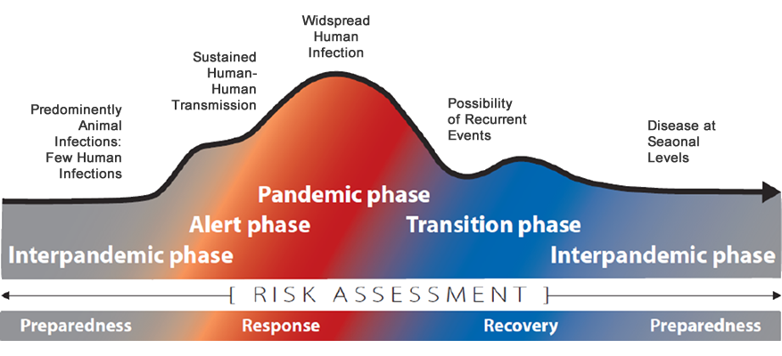
Illustration 1: WHO Pandemic Phases
Whereas some previous domestic (country-based) models accounted for whether influenza originated overseas, or locally, this model does not. Regardless of where it emerges from, an organisation’s response should be managed through task-specific guidance during individual phases, as detailed within Annex A.

Pandemic Management Organisation
The PMO is the collective term that describes the teams and individuals appearing within the illustration below. The PMO is primarily comprised of established groups, so as to leverage existing arrangements for rapid action and clarity of purpose.
The addition of the PMG is the key difference to a situation where the Crisis Management Team (CMT) may be activated and continuity arrangements simply invoked; the roles of Office and Line Managers are also augmented in this context, and they have key responsibilities in response to a symptomatic ORGANISATION worker.
The roles and responsibilities for each team/group/individual appear at Annex A (Roles and Responsibilities), and a list of Key Pandemic Management Contacts is included at Annex B.
Diagram 1: PMO Organisational Structure

Pandemic Reporting and Communications
Without deliberate planning and coordination, messages communicated during a pandemic alert have the potential to create unnecessary concern and confusion among stakeholders. All members of the PMO have a duty to ensure that communication is controlled and coordinated, and that appropriate messages are sent to all stakeholders when required.
Information may be distributed in various formats, including email, briefings, posters, websites and other means. With numerous communications channels available to key stakeholders, and multiple personnel involved in communicating messages, removing the potential for inconsistency and confusion must remain a key issue to monitor.
All messages should be defined and distributed in a manner that demonstrates consistency, transparency, timeliness and authority. Contact details should be included in all correspondence to provide the opportunity to easily address uncertainty and/or pursue additional details.

Reporting Cases of Influenza
It is critical that the reporting and escalation of pandemic related matters is conducted in a timely and accurate manner. By ensuring that the ‘right people get the message’ such communication serves to minimise confusion.
The process for reporting suspected influenza cases affecting workers is presented at Annex C, along with the form that must be submitted at the time. A ‘Register of Influenza Case History’ is also attached at Annex D and should be used as the basis for recording details submitted in reporting.

Document Templates
To promote consistency, uniformity and confidence in pandemic communications, it is important that messages are clear, distributed using mediums that are accessible to the intended audience and familiar in form.
Document templates for PMG purposes have been prepared and are available for download through the ORGANISATION Corporate Communications website on the INTRANET.
Once a document has been created it may be necessary to protect the uploaded version from unauthorised changes. One method to enforce this requirement is to create a .pdf file from MS Word and apply a password. The password should be securely stored at all times to both protect document integrity, and to apply it when changes to documents are authorised and necessary.

Workplace Pandemic Supplies and Resources
Management at each workplace should anticipate the need for an extended period of disruption during a pandemic. Office Managers should ensure that relevant hygiene supplies are sufficient to meet the needs of any realistic contingency, and are situated so as to be easily accessible by those who need/should use them.
A non-exhaustive list of supplies that should be considered is presented below; others should be considered, dependent upon specific conditions presenting at the time.
- Alcohol-based hand sanitiser.  - Face masks (refer to Annex G).  - Disinfecting floor cleaning supplies.  - Waste disposal bags. | - Disinfectants and wipes.  - Cleaning cloths.  - Latex gloves.

Risk Management
Despite the pre-defined nature of arrangements detailed within this Plan, the implementation of a risk-based approach is always encouraged. Such an approach permits decisions to be made with regard to health and safety obligations and minimises the risk of inefficiency that may otherwise affect the organisation.
As an example, a workplace may be under consideration for closure through a lack of staff, or because it poses an unacceptable level of risk to employees or others. Where a decision is to be made on evacuation of an office, the PMG should assess the net benefits of closing down against the ability to manage the risk without comprising the organisation’s health and safety obligations.
Some business units may be able to manage the risk with mitigating controls in place, but will need to balance any decision against various domestic and international regulatory obligations.

Review and Improvement
Business Resilience Program-related plans and arrangements should be subject to both compliance audits and reviews periodically, to ensure the continuing integrity and effectiveness of all elements. Such activities should be conducted by ORGANISATION, in accordance with internal and external auditing/assurance arrangements.

Training, Testing and Exercising
Shifting business and reporting lines, dependencies, personnel and other variables are common in large organisations. It is therefore critical that pandemic documentation is maintained to ensure currency and effectiveness.
Training and testing are equally important activities, ensuring that designated personnel are capable of performing their role confidently and that plans are current.
Training and testing options include, but are not limited to:
Training | Testing/Exercising
- Seminars/Conferences  - Tabletop Exercises/Workshops  - Live Exercises/full interruption  - Formal Courses  - Group Briefs/Presentations | - Audits and Reviews  - Tabletop Exercises/Workshops  - Live Exercises/full interruption  - Structured Walk-through  - Comparison against checklists
Table 1: Training and Testing Options

Annex A: Roles and Responsibilities

Crisis Management Team
The CMT is responsible for implementing the Crisis Management Plan (CMP), which is designed to provide the senior level leadership needed during an event/incident/issue that reaches a level considered to be a crisis.
Phase | Tasks | Remarks
All phases. | Review and implement CMP. | The PMG will assume day-to-day responsibility and management for the response, on behalf of the CMT.

Pandemic Management Group (PMG) Leader
The PMG Leader, via the PMG, is responsible for invoking this plan and implementing associated pandemic response arrangements throughout each phase detailed below. The PMG Leader also acts as primary point of contact to the CMT and has its authority to direct PMG members in the achievement of pandemic objectives.
To ensure adequate authority and resourcing, the PMG Leader is ideally a member of executive management, with the following general leadership responsibilities throughout all stages:
- Schedule, convene and chair PMG meetings.
- Approve and authorise the release of correspondence generated by the PMG.
- Provide planned and ad-hoc briefings to, and take direction from the CMT, to ensure consistency in organisational knowledge and approaches to pandemic management.
- Consider out of session pandemic related information/requests where time sensitivity prevents delay until the next scheduled meeting.
- Inform the CEO and Group Communications Manager of any media attention focused on ORGANISATION.
- Strive for consistency in pandemic management and initiatives across the organisation.
Phases | Tasks | Remarks
All | Check that all PMP contact details are up to date
 | Communicate in a coordinated and consistent manner

Phase | Tasks | Remarks
Interpandemic  Preparing | Identify and mitigate risks associated with the outbreak of a pandemic
 | Conduct pandemic response reviews, testing and continually update/improve this plan | As an integrated element of the ORGANISATION Business Resilience Program
 | Monitor media and authoritative websites to identify emerging threats | WHO, CDC, DFAT, US Dept. of State
 | Disseminate this Plan, or relevant elements within it, to all appointees and other key stakeholders and ensure that they are familiar with their roles
 | Confirm arrangements for (effective) remote access to resources across the organisation
 | Ensure that awareness exists for the need for communications to be culturally and linguistically appropriate
 | Develop 24/7 means (e.g. hotline, dedicated website) for communicating pandemic status updates/actions to employees and service delivery news to vendors and customers | To be launched/linked as soon as Alert stage is declared - post relevant details from this Plan (e.g. reporting)
 | Develop a system to account for travelling workers | Travel Tracking system, check-in system etc.
 | Confirm Administrative Support for the PMG | See section below this table; it is likely that the appointee will remain unknown until they are required to support the PMG
Alert  Responding Early | Engage with CMT to agree general strategy, limits and constraints
 | Consider criteria and formally announce the transition to this phase; define a communications schedule | Communicate this schedule - at worst monthly updates should be provided, ideally fortnightly
 | Develop organisational response strategies for influenza spreading in different countries progressively/rapidly | For example, consider staggering common responses in different countries, based on infections – implement these once pre-defined triggers have been observed
 | Identify travellers to affected regions and devise strategies to limit the risk of passing on influenza to other workers. | Consider self-isolation periods upon return
 | Implement tasks in Annex C (Suspected Pandemic Influenza Case Response & Reporting) in the event that an ORGANISATION worker becomes symptomatic
 | Prepare and distribute contextualised posters and worker notices to Office Managers to post within workplaces
 | Request Human Resources representative to review Annex H (Pandemic Flu Policies), and update and release each at the appropriate time
 | Determine the need and arrange for appropriate Personal Protective Equipment (PPE) based on WHO and CDC recommendations and coordinate delivery of the necessary training
Pandemic  Responding | Consider criteria and formally announce the transition to this phase
 | Refine and adjust response strategies as the influenza spreads through different countries
 | Implement tasks in Annex C (Suspected Pandemic Influenza Case Response & Reporting) in the event that an ORGANISATION worker becomes symptomatic
Transition  Responding & Recovering | Consider criteria and formally announce the transition to this phase
 | Continue to respond to symptomatic individuals per previous phase
 | Assess availability of medical, mental health, and social services for employees after the pandemic
Interpandemic Recovering & Preparing | Consider criteria and formally announce the transition to this phase
 | Conduct a post-pandemic review of the response, document lessons learned | Update this and other plans
 | Prepare for possible follow-on pandemic waves

-A3-

PMG Administrative Support
Phases | Tasks | Remarks
All | Prepare and distribute PMG meeting agendas and a record of minutes to relevant stakeholders
 | Ensure all Pandemic Committee records are retained/archived for a minimum period of seven years after recovery from a pandemic.
 | Remain responsive to the needs of the PMG Leader and members of the PMG

Office Managers
Phase | Tasks | Remarks
Interpandemic  Preparing | Maintain a baseline level of office hygiene stores
 | Participate in pandemic-related preparatory activities, initiated by the PMG
 | Educate office staff in good office hygiene practices
Alert  Responding Early | Implement tasks per Annex C (Suspected Pandemic Influenza Case Response & Reporting)
 | Stocktake and increase office hygiene stores
 | Identify any increased facilities maintenance required and place critical suppliers on standby
Pandemic  Responding | Implement tasks per Annex C (Suspected Pandemic Influenza Case Response & Reporting)
Transition  Responding & Recovering | Implement tasks per Annex C (Suspected Pandemic Influenza Case Response & Reporting)
Interpandemic  Recovering & Preparing | Replenish office hygiene stores to baseline levels
 | Be prepared to provide feedback to the PMG on the response process

Business Continuity Plan (BCP) Owners
Phase | Tasks | Remarks
All phases. | Prepare, review, exercise, improve and implement BCPs. | While typified by its extended timeframe, in the context of business continuity pandemic is one of many events that should be planned for. Planning should incorporate contingencies for prolonged denial of access to offices and travel.
 | Liaise with Critical Business Function Managers to ensure that contingency arrangements are tailored to the nuances of a pandemic | For example:  - Cross-training of personnel  - Extended absence from closed offices

Critical Business Function Managers
Phase | Tasks | Remarks
All phases. | Prepare, review, improve and execute local actions to sustain critical business functions at tolerable levels, or restore them when inactive. | While typified by its extended timeframe, in the context of business continuity pandemic is one of many events that should be planned for. Planning should incorporate contingencies for prolonged denial of access to offices and travel.

Line Managers
Phase | Tasks | Remarks
Alert  Responding Early | Implement tasks per Annex C (Suspected Pandemic Influenza Case Response & Reporting)
Pandemic
Responding
Transition
Responding & Recovering

Annex B: Key Pandemic Management Contacts
PMO Role | Name & Role | Contact Details
BCP Owners | Refer to individual BCPs | -
CMT | Refer to CMP | -
Critical Business  Function Managers | Refer to individual BCPs | -
Office Manager  LOCATION | Primary: NAME | MOBILE | DESK  EMAIL
 | Alternate: NAME | MOBILE | DESK  EMAIL
Office Manager  LOCATION | Primary: NAME | MOBILE | DESK  EMAIL
 | Alternate: NAME | MOBILE | DESK  EMAIL
Office Manager  LOCATION | Primary: NAME | MOBILE | DESK  EMAIL
 | Alternate: NAME | MOBILE | DESK  EMAIL
PMG Hotline | PHONE | EMAIL
PMG Leader | Primary: NAME | MOBILE | DESK  EMAIL
 | Alternate: NAME | MOBILE | DESK  EMAIL
PMG Member | Primary: NAME | MOBILE | DESK  EMAIL
 | Alternate: NAME | MOBILE | DESK  EMAIL
PMG Member | Primary: NAME | MOBILE | DESK  EMAIL
 | Alternate: NAME | MOBILE | DESK  EMAIL
PMG Member | Primary: NAME | MOBILE | DESK  EMAIL
 | Alternate: NAME | MOBILE | DESK  EMAIL

Annex C: Suspected Pandemic Influenza Case Response & Reporting
Outside the Workplace (during Alert, Pandemic and Transition Stages)
Condition | Act | Communicate | Responsible
ORGANISATION worker displays symptoms of influenza outside the workplace. Symptoms include:  - Fever  - Flu-like symptoms such as coughing, sore throat and fatigue  - Shortness of breath | Symptomatic worker should don a facemask and seek medical attention (i.e. Doctor/ Hospital/ Emergency Services) | Call ahead to describe symptoms and advise of any recent travel | Affected worker
 |  | Notify line manager by phone at the earliest opportunity | Affected worker/representative
 |  | Notify the worker to self-isolate until diagnosed, then report details to the local Office Manager and Senior local business leader | Line manager
 | - Submit “Suspected Pandemic Influenza Case Reporting Form” to the PMG (after “Communicate” tasks)  - If delays are expected in receiving a response from the PMG (e.g. due to time-zone impacts) take immediate actions necessary to protect other workers, consistent with previous PMG deliberations/discussions (e.g. evacuate workplace till thoroughly cleaned if worker recently attended) | - Notify the PMG  - Follow up reporting to indicate response taken (if relevant) | Senior local business leader
 | Enact response strategy (e.g. engage cleaners), in consultation with the Senior local business leader | Notify the Building Manager | Office Manager
 | Register details within Annex D (Register of Influenza Case History) and update register as information becomes available | Liaise with the Senior local business leader in developing a communication strategy and notify/direct stakeholders, including the CMT Leader (Corporate Communications to be prepared for media enquiries); include return to work arrangements where relevant | PMG Leader
 |  | Report influenza status to Line Manager as soon confirmed | Affected worker/representative
 |  | Report influenza status to local Office Manager and Senior local business leader | Line manager
 |  | - Report influenza status to the PMG  - Notify Office Manager | Senior local business leader
 | Update Annex D (Register of Influenza Case History) |  | PMG Leader

-C2-
Within the Workplace (during Alert, Pandemic and Transition Stages)
Condition | Act | Communicate | Responsible
ORGANISATION worker displays symptoms of influenza with an ORGANISATION workplace. Symptoms include:  - Fever  - Flu-like symptoms such as coughing, sore throat and fatigue  - Shortness of breath  Non-workers displaying such symptoms within a workplace should be offered a facemask and directed off the premises/ tenancy and encouraged to seek medical attention.  Any other relevant actions listed in this table should then also be considered. | Symptomatic worker must don a facemask immediately |  | Affected worker/person observing affected worker
 | Depart the office environment immediately and seek medical attention (i.e. Doctor/Hospital/ Emergency Services) | - Notify line manager by phone at the earliest opportunity  - Call ahead to describe symptoms and advise of any recent travel | Affected worker
 |  | Notify the worker to self-isolate until diagnosed, then report details to the local Human Resources Representative and Senior Management | Line manager
 | - Submit “Suspected Pandemic Influenza Case Reporting Form” to the PMG (after “Communicate” tasks)  - If delays are expected in receiving a response from the PMG (e.g. due to time-zone impacts) take immediate actions necessary to protect other workers, consistent with previous PMG deliberations/discussions (e.g. evacuate workplace till thoroughly cleaned if worker recently attended) | - Notify the PMG  - Follow up reporting to indicate response taken (if relevant) | Senior local business leader
 | Enact response strategy (e.g. engage cleaners), in consultation with the Senior local business leader | Notify the Building Manager | Office Manager
 | Register details within Annex D (Register of Influenza Case History) and update register as information becomes available | Liaise with the Senior local business leader in developing a communication strategy and notify/direct stakeholders, including the CMT Leader (Corporate Communications to be prepared for media enquiries); include return to work arrangements where relevant | PMG Leader
 |  | Report influenza status to Line Manager as soon confirmed | Affected worker/representative
 |  | Report influenza status to local Office Manager and Senior local business leader | Line manager
 |  | - Report influenza status to the PMG  - Notify Office Manager | Senior local business leader
 | Update Annex D (Register of Influenza Case History) |  | PMG Leader

-C3-

Suspected Pandemic Influenza Case Reporting Form
The following report is available through the ORGANISATION INTRANET Pandemic Resources Page and should submitted to the PMG as soon as possible after initial reporting.
Purpose and Applicability
The purpose of this form is to provide information to the PMG to aid in the process of managing suspected and actual cases of pandemic influenza infection.
Instructions for Completing this Form
- Name of Affected Person: Insert the name of the affected individual.
- Status: Indicate whether the individual is an employee or other ‘worker’ (per W/OHS Laws).
- Details: Insert all details to identify and contact the affected individual.
- Situation Status: provide details on current situation.
- Date Symptoms Detected: Indicate date that symptoms were first identified.
- Symptoms Displayed: Indicate visible and other symptoms displayed by individual.
- Location Detected: Indicate where the individual was diagnosed.
- Return to Work Date: Indicate the date that individual returned/is expected to return to the workplace. If a date is not yet known, indicate ‘Unknown’.
- Comments: Provide additional background details on any aspect of the situation.
- Details of Person Completing Form: Provide details for follow-up purposes.
Submitting this Form
Upon completion, email this form to:
Area: | Pandemic Management Group
Email: | EMAIL
-

-C4-
Suspected Pandemic Influenza Case Reporting Form
Name of Affected Person:
Employment Status: | Employee: | Contractor: |  |  | Other:
Infection Status: | Confirmed: | Suspected: |  |  | Other:
Details: | Home Phone:
 | Mobile:
 | Email Address:
 | Work Details/Other:
 | Work Address:
 | Line Manager:
Situation Status: | Hospital: |  |  | Self-isolated: |  |  | Returned to Work:
 | Other:
Date Symptoms Detected:
Symptoms Displayed:
Location Detected:
Return to Work Date:
Comments: | (Provide as much detail as possible on the location, status and any risk posed by the affected individual. If they have been diagnosed positive to pandemic influenza indicate details here).
Details of Person  Completing Form: | Submitted By:
 | Appointment/Role:
 | Phone:
 | Email:
 | Address:
 | Date:
To be handled in the strictest of confidence (once completed)

Annex D: Register of Influenza Case History
Name | Status | State and Country | Business Unit | Accommodation Type | Situation Status | Date  Detected | Remarks

Annex E: Pandemic Case Contact Trace Register
Where the severity of a virus necessitates, those personnel with whom the symptomatic/confirmed individual has come into close contact should be traced for follow up and preventative purposes. This requirement will vary, depending upon the situation and advice of Government, and additional details to those indicated in the table below may require to be collected.
To ensure accuracy and effectiveness in data collection, reference should be made to current Government requirements for contact tracing, including the requirement to factor in incubation period (i.e. how far back records should extend).
Pandemic Case Contact Trace Register
Symptomatic Individual name:
Date: | Time: | Contact Name: | Mobile No: | Reason | Location | Duration | Contact Level* | Contacted | Comments
DD/MM/YY | HH:MM | Name | Number | Meeting / Work / Lunch | Place | in hrs | 1-4 | Yes or No | Remarks
Other Comments:

* Contact Level
1 – Physical proximity 1-2m and for more than 2 hrs
2 – Physical proximity 1-2m but for less than 2 hrs
3 – Physical proximity greater than 2m and for more than 2 hrs
4 – Physical proximity greater than 2m and for less than 2 hrs

Annex F: Privacy and Ethical Considerations
In the event of an influenza pandemic, a number of difficult decisions will sometimes need to be made about a wide range of response and recovery issues. The following considerations should be an integral element of all decision making and pandemic management activities.
- Protection of people as a first priority.
- Stewardship: leaders must strive to make good decisions based on best available evidence.
- Trust: that decision makers strive to communicate in a timely and transparent manner.
- Equity: making decisions in an equitable manner, recognising the special needs, cultural values and religious beliefs of different members of the Group.
- Proportionality: ensuring that measures taken are proportionate to the threat.
- Reciprocity: ensuring that when individuals are asked to take measures or perform duties for the benefit of the organisation as a whole, their acts are appropriately recognised, and legitimate needs associated with these acts are met where possible.
- Individual liberty: ensuring that the rights of the individual are upheld as much as possible.
- Privacy and confidentiality: both are important and should be protected, however, under extraordinary conditions during a severe pandemic, it may be necessary for some elements to be overridden to protect the health and safety of others.

Annex G: Face Masks
The following image illustrates face mask options for protecting against the spread of influenza; pricing is presented in $AUD.
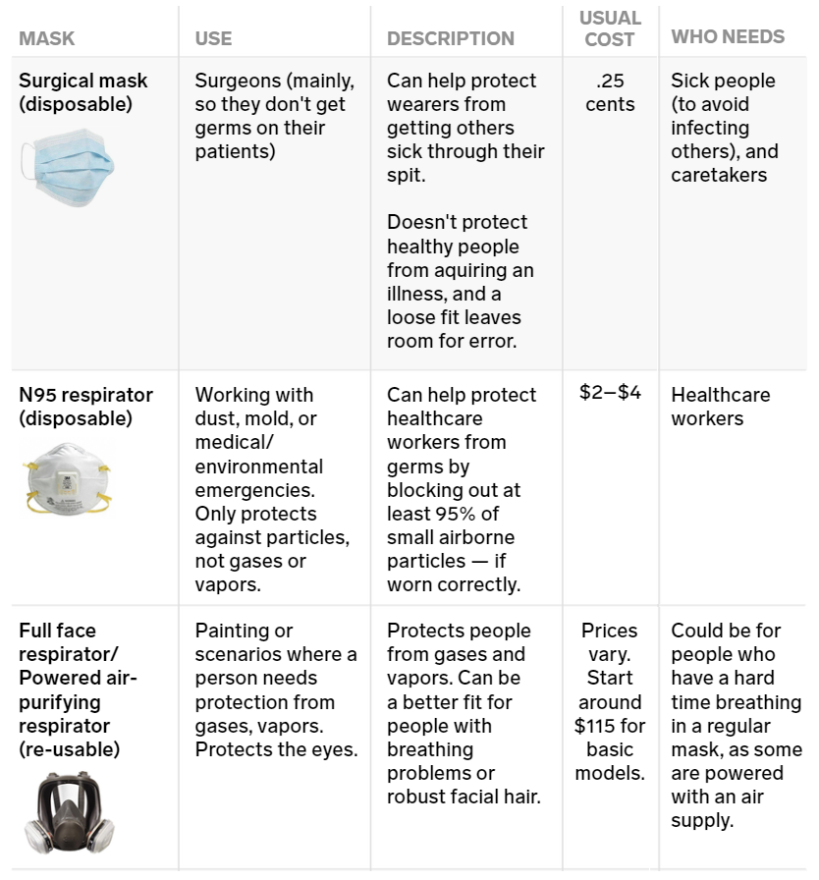
(Image courtesy of Business Insider Australia)

Annex H: Pandemic Flu Policies
The following policies, or revised variations of them, should be communicated at the appropriate time.
- ORGANISATION will make every effort to ensure that the employment conditions of its employees are not adversely affected during a pandemic event.
- ORGANISATION balance the requirement to continue services with the well-being and legitimate personal, family and community responsibilities of employees.
- Where workplace arrangements need to be varied to accommodate business continuity planning for a pandemic event, these arrangements will be:
  - made in advance and in consultation with employees, employee representatives and/or relevant unions where required;
  - within the relevant legislative framework; and
  - applied fairly and equitably in workplaces.
- Upon application, an employee who has exhausted their sick leave accruals will be entitled to 20 days paid “Special Pandemic Leave” for use when the employee is unable to attend work because they:
  - have actual or suspected viral infection; and/or
  - are required to care for family or household member/s who have actual or suspected viral infection; and/or
  - are required to care for children as a result of the closure of school or child care centres; and/or
  - are unable to access public transport to travel to work.
- Once Special Pandemic Leave is exhausted, employees will be expected to access their existing recreation leave and long service leave entitlements. Where an employee seeks to access accrued long service leave in accordance with this Directive, the minimum continuous service period of seven years on Long Service Leave shall not apply.
- Employees will be paid ordinary time salary if they are willing and able to attend work but are directed by ORGANISATION not to attend work.
- Employees who:
  - Are directed to attend their usual place of work, will only be so directed if ORGANISATION has determined that the workplace poses minimum/no risk to that employee.
  - Refuse a reasonable direction to attend work for reasons other than those provided in this policy or another reasonable explanation may be disciplined or suspended without pay.
  - Advise they are exhibiting symptoms of the virus should be directed to remain at home until they are cleared to return to work.
  - Exhibit symptoms of the virus while at work should be directed to leave the workplace.
  - Have had the virus or who have been exposed to the virus should be advised not to return to work until after the minimum prescribed time has elapsed.
  - Are absent from work as a result of the influenza pandemic will not be required to submit a medical certificate. Instead, they will be required to provide a copy of a record of attendance at a medical facility or such other document which satisfies ORGANISATION requirements.

